**25447Eti**

**Exhibit "A"**

**Situated in the State of Ohio, City of Hilliard, Franklin County, Ohio and known as Lots One (1) to Ninety-Three (93), both inclusive, and an area designated "Reserve A" of HERITAGE LAKES SECTION 1, as the same are numbered and delineated on the plat thereof, in Plat Book 79, pages 42, 43 and 44, Recorder's Office, Franklin County, Ohio.**

**1031AM**

|  |  |
| --- | --- |
| **27798003** |  |

|  |  |  |
| --- | --- | --- |
| **FIRST SUPPLEMENT  TO  DECLARATION OF COVENANTS,  CONDITIONS AND RESTRICTIONS  FOR  HERITAGE LAKES** | **MOM MIMI CO4 COO**  **NOV 1 1994  Reran B. METCALF, PONDER** | |
|  |  |

**This First Supplement to the Declaration of Covenants, Copditions and Restrictions for Heritage Lakes is executed and delivered this3f day of Alio to-t 1994 by Planned Development Company of Ohio, an Ohio corporation ("Declarant".**



BACKOSILM

1. **A plan of covenants, easements, restrictions and assessments for Heritage Lakes in the City of }Ward, Franklin County, Ohio, was created by a declaration thereof (the "Declaration") recorded in Official Records 25447.D07, Recorder's Office, Franklin County, Ohio with respect to the Property (as defined in the Declaration).**
2. **Pursuant to the provisions of Section 2.2 of the Declaration, Declarant reserved the right to subject additional property to the provisions of the Declaration.**
3. **Declarant desires by this instument to subject the following described property to la provisions of the Declaration:**

**NOW THEREFORE, Declarant thereby declares that the following described real estate:**



**Situated in the State of Ohio, County of Franklin and City of Hilliard, and known as Lots 94 through 104 and Lots 148 through 158, both inclusive, of HERITAGE LAKES Section 2 Phase 1, as the same are numbered and delineated on the plat thereof in Plat Book 81, pages 4 and 5, Recorder's Office, Franklin County, Ohio**



**all of which is owned by Declarant, shall be held, transferred, sold, conveyed, improved and occupied subject to all of the covenants, conditions and restrictions set forth in the Declaration and such property shall be and hereby is deemed part of the Property (as defined in the Declaration).**

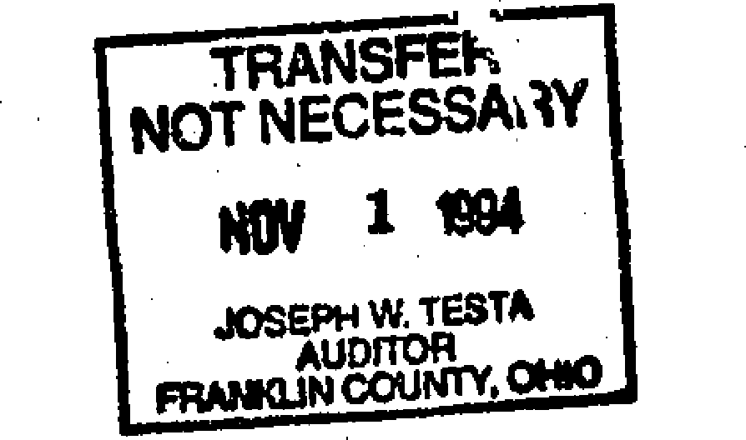

**CONVEYANCE TAX**

**EXEMPT**

**JOSEP TESTA**

**jsznoi HA4ML,**

|  |  |  |  |
| --- | --- | --- | --- |
| *.0••••* • tk. | **r** |  | **• r'** *,,e* . P., |
|  |  |

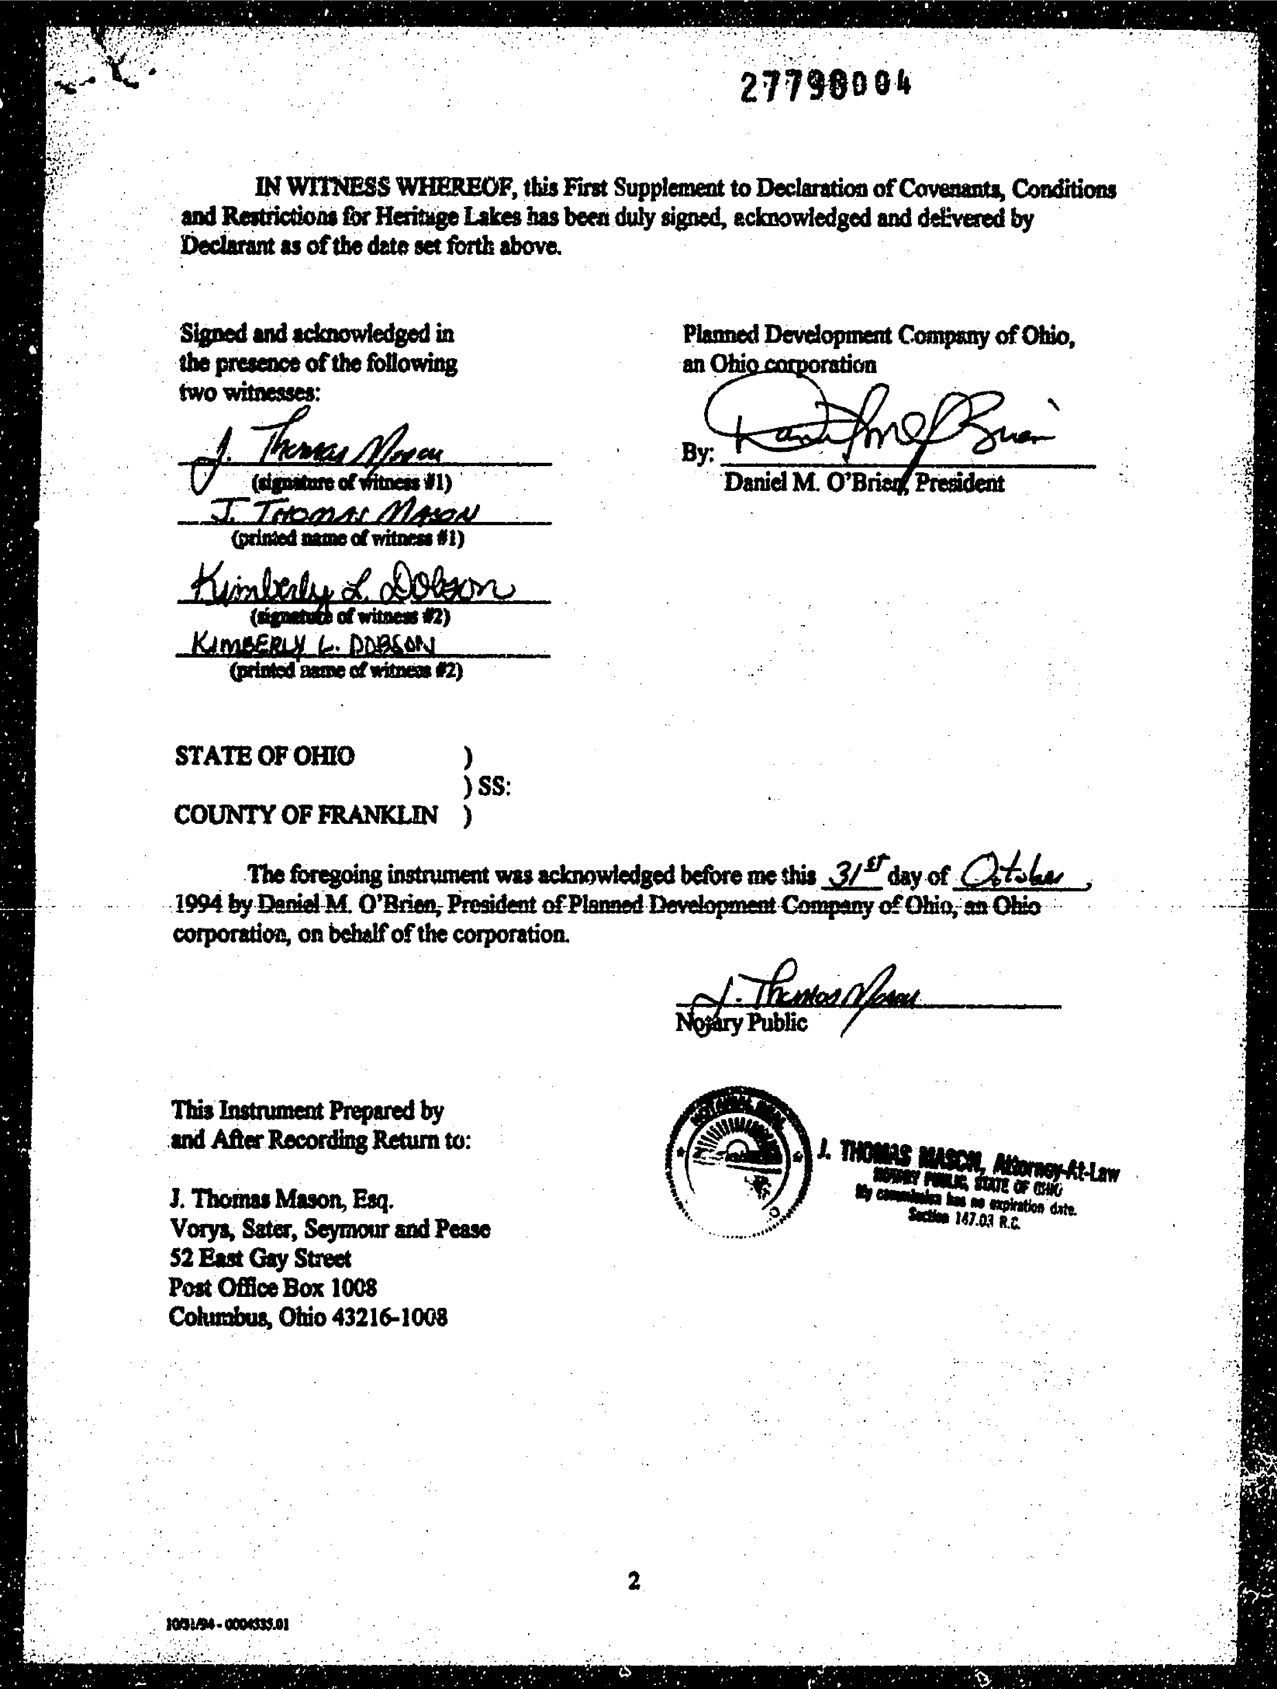

**J. Thomas Mason, Esq.**

**Vorys, Sara, Seymour and Pease 52 Ea Gay Street**

**Post Office Box 1008**

**Columbus, Ohio 43216-1008**

acrni **Hay**



**DECLARATION OF COVENANTS, AUG 28 1995**

**CONDITIONS AND RESTRICTIONS RICKARD 8. METCALF.**

**FOR moors Fit s**

**HERITAGE LAKES**

**SECOND SUPPLEMENT 1 3 0 PAI,**

**MOM IIIMPI1N CA. OHIO**

**TO**

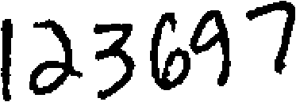

**This Second Supplement to the Declaration of Covenants, Conditions and Restrictions for Heritage Lakes is executed and delivered this 5- day of 1995 by Planned**

**Development Company of Ohio, an Ohio corporation Med ).**

**BACKGROUND**

1. 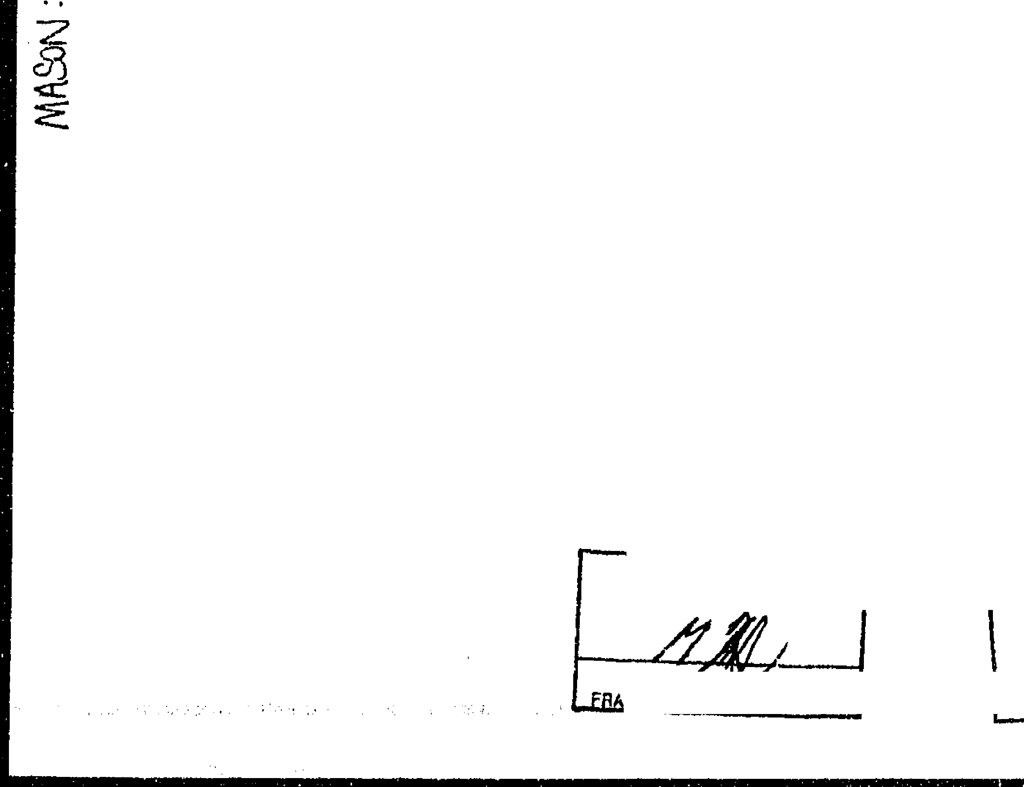**A plan of covenants, easements, restrictions and assessments for Heritage Lakes in the City of Hilliard, Franklin County, Ohio, was created by a declaration recorded in Official Records 25447-D07, Re; Border's Office, Franklin County, Ohio with respect to the Property (as defined in the Declaration) as amended by that certain First Supplement to Declaration of Covenants, Conditions and Restrictions for Heritage Lakes, recorded in Official Records 27798­D03, Recorder's Office, Franklin County, Ohio (collectively, the "Declaration").**



**0**

1. **Declarant desires to amend the Declaration as permitted by § 9.1 thereof.**

**NOW THEREFORE, Declarant hereby declares that the Declaration shall be and hereby is amended by adding the following new Section 6.6, titled "No Rights in Golf Course," thereto:**

**Section 6.6, No sights in Golf Come. Each Owner, by acceptance of a deed to any Lot, acknowledges and agrees that neither the Owner nor the Owners successors in interest, by purchasing and acquiring title to a Lot, shall acquire any right, license, easement, title, membership or other interest in or to use of the Golf Course or amenities developed on or provided in connection with the Golf Course. The Association has no legal or equitable interest in the Golf Course and the Golf Course is not part of the Common Property. Any such use and enjoyment of the Golf Course is not connected with nor based upon ownership of a Lot. The Golf Course Owner has the sole and exclusive right to establish, from time to time, the terms and conditions of use of the Golf Course.**

**CONVEYANCE TAX**

**EXEMPT**

**JOSEPH TA**

K **MT**



**TRANSFER   
NOT NECESSARY**

**AUG 28 1995**

**JOSEPH W. TESTA   
AUDITOR   
FFIANKUN COUNTY. OHIO**



|  |  |
| --- | --- |
|  | ***)9%-11 /106*** |

**IN WITNESS WHEREOF, this Second Supplement to Declaration of Covenants, Conditions and Restrictions for Heritage Lakes has *been* duly signed, acknowledged and delivered by Declarant as of the date set forth above.**

**Signed and acknowledged in the presence of the following two witnesses:**



**tary Public /**

**IL VINO Slink alitelpAttaw   
ail Paw am or ow**

**1/ sworn fin mimeo dna.   
*Wks* WAS R.C.**

**5( CO 1**

**fitness #1)**

**Planned Development Company ..)f Ohio, an Ohio core_ration**

|  |
| --- |
| **By:**  **Daniel M. O'Brie resident** |

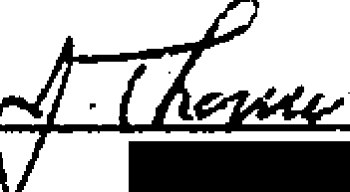

**(printed name of witness #1)**

**(signature of mess #2)**

**77,-,4,9"); (printed namo of witness #2)**

|  |
| --- |
| **STATE OF OHIO**  **) SS: COUNTY OF FRANKLIN )**  **The foregoing instrument was acknowledged before me this al-5day of**  **1995 by Daniel M. O'Brien, President of Planned Development Company of Ohio, an Ohio corporation, on behalf of the corporation.** |

**This Instrument Prepared by and After Recording Return to:**

**I. Thomas Mason, Esq.**

**Vorys, Sater, Seymour and Pease 52 East Gay Street**

**Post Office Box 1008**

**Columbus, Ohio 43216-1008**

**OV03195 • CO 12437.01**

h.

|  |  |
| --- | --- |
| **33%7AD I**  **l'HIRD SUPPLEMENT TO** | **310PM**  **TIME ---**  **RECORDER FRANKLIN ca. OHIO**  **DEC 2 7 1996** |

|  |
| --- |
| **DECLARATION OF COVENANTS, CONDITIONS**  **RICHARD a METCALF, RECOoyER**  **AND RESTRICTIONS FOR HERITAGE LAKES**  **lawRDER'S FEE** |

**This Third Supplement to the Declaration of Covenants, Conditions vd Restrictions for Heritage Lakes (the "Third Supplement") is executed and delivered this .611-7day of December, 1996 by Planned Development Company of Ohio, an Ohio corporation rDeclarant").**

**BACKS a= 409730**

**A. A plan of covenants, easements, restrictions and assessments for Heritage Lakes in**

**the City of Hilliard, Franklin County, Ohio, was created by a declaration thereof recorded in**

**or .11**

**rGDfacha jINQPit251111M Reoardzr's Office, Franklin County, Ohio (the "Public Records"), as**

**•**

**■**

**1:1**

**c tin CL Fi , •**

**amended by that certain First Supplement to Declaration of Covenants, Conditions and Restrictions for Heritage Lakes (the "First Supplement"), recorded in Official Records 27798- D03 of the Public Records, as anther amended by that certain Second SupplaneM to Declaration of Covenants, Conditions and Restrictions for Heritage Lakes (the "Second Supplement"), recorded in Official Records 29871-H04 of the Public Records (collectively, the "Declaration"; unless otherwise defined in this Third Supplement, all capitalized terms and phrases contained in this Third Supplement shall have the same meanings as ascribed to each in the Declaration).**

1. **Pursuant to the provisions of Section 2.2 of the Declaration, r )clarant reserved the right to subject additional property to the provisions of the Declaration.**
2. **Pursuant to the provisions of Section 9.1 of the Declaration, Declarant reserved the right to amend the Declaration.**
3. **Declarant desires by this Third Supplement to subject the following described property to the provisions of the Declaration and to otherwise amend the Declaration as more particularly provided in this Third Supplement.**

•

**NOW THEREFORE, Declarant thereby declares that:**

|  |
| --- |
| **1. Aggithsuilltmeity. The approximate 2.144 acre tract of real prorerty**  **more particularly described in Exhibit A to this Third Supplement, all of which is owned by Declarant, shall be held, transferred, sold, conveyed, improved and occupied subject to all of the covenants, conditions and restrictions set forth in the Declaration and such property shall be and hereby is deemed part of the Property and, for purposes of the Declaration, a Lot.** |

|  |
| --- |
| **2. pefirtitiops. Article I of the Declaration, titled "Definitions," is hereby**  **amended, supplemented and modified as follows:**  **C. r; AUCE T**  **Nr'IT t‘** |

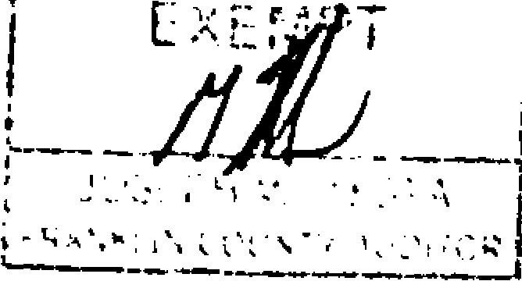

|  |  |
| --- | --- |
| **F. C n 7** | **lipcts** |
|  |  |
|  |  |

**: 947A 02**

1. **Let. Section 1.24 of the Declaration is hereby amended by deleting   
   this section in its entirety and substituting the following in lieu thereof!**

**Section 1,24. A Lot shall mean a portion of the Property designated by metes and bounds description and/or on a Plat as a separate building lot and containing a separate tax identification number, and shall include both Developed Lots and Undeveloped Lots.**

1. **COMMA Pope*. Section 112 of the Declaration is hereby   
   amended by deleting this Section in its entirety and substituting the following in lieu thereof!**

**ion 1.12. Common Property shall mean all portions of the Property (including any Scenic Common Property) that are intended for the common use and enjoyment of Members (e.g., the entryway to Heritage Lakes and the amenities related thereto) including, without limitation, the entryway fences, walls, ponds, signs, irrigation system and landscaping (including the red maple trees planted between the curb and sidewalk along Heritage Lakes Drive between Alton-Darby Road and the intersection of Heritage View Court and Heritage Point Court) and which are identified as Common Property by the Association and/or Declarant or which are dedicated to the Association on a Plat of Heritage Lakes or which are conveyed by Declarant to the Association, together with all personal property related thereto, and all real and personal property that may subsequently be acquired by the Association for the common use and enjoyment of the Members.**

1. **ScenicCommon Property. Article I of the Declaration is further   
   amended by adding *the* following new Sections 1.37, 1.38 and 1.39 to such Article:**

**Section 137. Scenic Common Property shall mean any portion of the Common Property designated as Scenic Common Property in this Declaration, by Declarant or by the Association.**

**Section J.38. Scenic Common Area shall mean that area more particularly described on Exhibit B to this Declaration.**

**$ectjgn J.39. Scenic Common Area Easement shall mean the easement reserved by Declarant on. over, through and under the Scenic Common Area, for the benefit of Declarant and the Association, in Section 6.6 of this Declaration.**

**3. Scenic Common Area. Article IV of the Declaration, titled "Common**

**Property," is hereby amended by adding the following new Section 4.5 to such Article:**

**2**

**339147A 03**

**Section 4.5. Scenic _Commra/D2RamikAta. Any Scenic Common Property shall be maintained by the Association as provided in Section 4.3 of this Declaration. However, and notwithstanding any contrary provision in this Declaration, Members shall not be entitled to any access over or use of any *such* Scenic Common Property. The lakes, waterfalls, stonework, fencing, utilities and related landscape and site improvements located in the Scenic Common Area, all of which is Common Property under this Declaration, shall be deemed Scenic Common Property.**

1. **Scenic Common Area Easement. Article VI of the Declaration, titled "Easements, Rights of Entry," is hereby amended by adding the following new Section 6,6 to such Article:**

**itvliQLOAScsinreSommimAnaLeascamat. Declarant reserves to itself and to the Association a perpetual easement in, through, under and over the Scenic Common Area. No Improvements shall be placed or permitted to remain within the Scenic Common Area unless such Improvements have been installed by Declarant and/or the Association or approved in accordance with the terms of this Declaration.**

1. **Exhibits. The Declaration is further amended by adding to the Declaration   
   as Exhibit B the legal description attached to this Third Supplement as Exhibit B.**
2. **Ratification of Declaration. Except as amended, supplemented and   
   modified by the First Supplement, the Second Supplement ribd this Third Supplement, Declarant hereby ratifies and affirms the Declaration.**

**IN WITNESS WHEREOF, this Third Supplement to Declaration of Covenants, Conditions and Restrictions for Heritage Lakes has been duly signed, acknowledged and delivered by Declarant as of the date set forth above.**

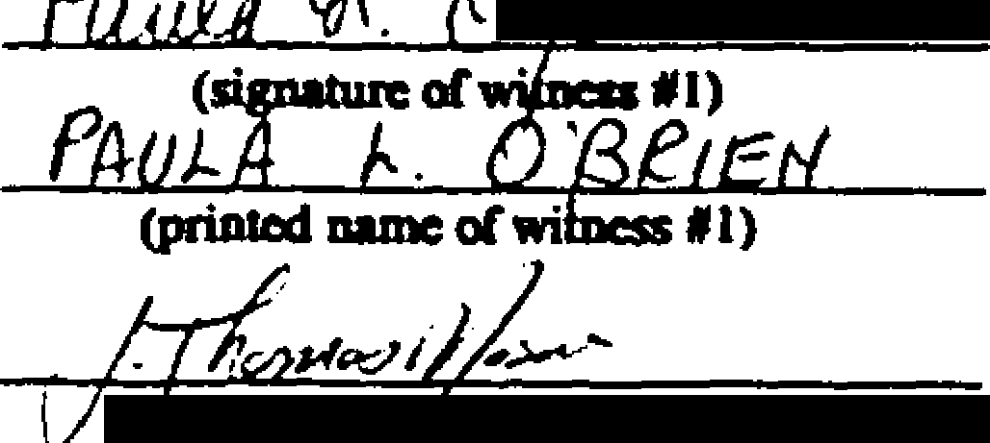**Planned Development Company of Ohio, an Ohio corporation**

**Signed and acknowledged in the presence of the following two witnesses:**

***J***

**By:**

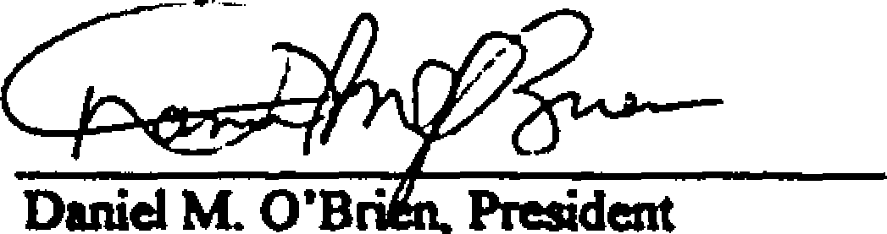

**(signattue6,witnepp2)**

**- ric177.41 *7,i47c>* 4) (printed name of witness #2)**

**3**

339471104

**STATE OF OHIO**

**) SS: COT 'WY OF FRANKLIN )**

**The foregoing instrument was acknowledged before me this  */so*  day of DeCeMbar, 1996 by Daniel M. O'Brien, President of Planned Development Company of Ohio, an Ohio corporation, on behalf of the corporation.**

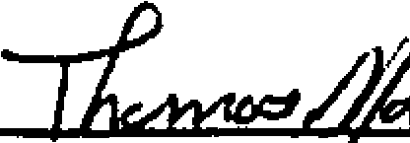

**NovPublic**

**J. Thomas Mason, *Esq.***

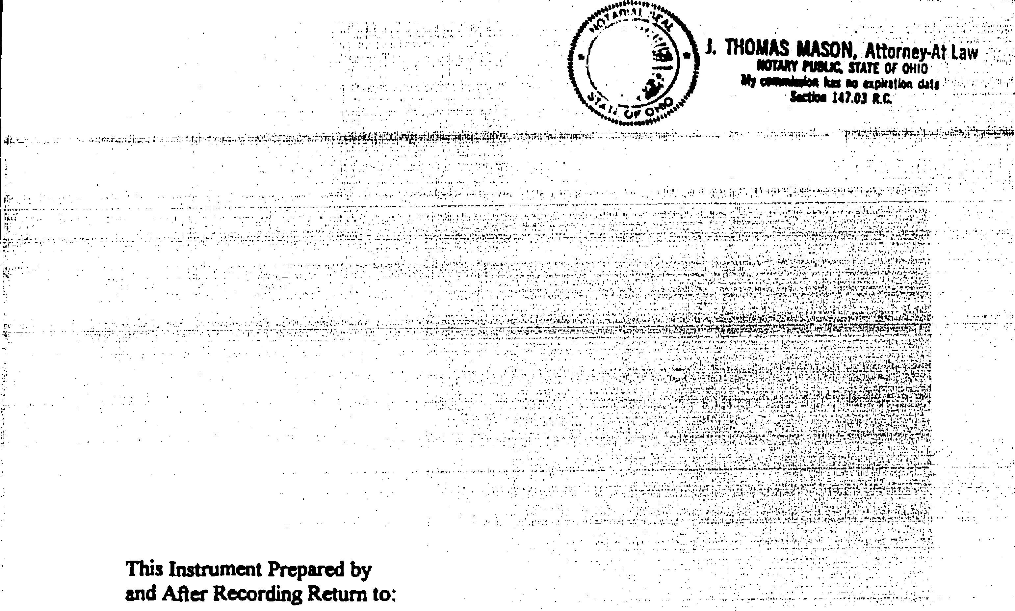

**J. THOMAS MASON, Attorney-At Li**

**110DXf IVOUC. STATE OF OHIO**

**My commiain kis No upitation daft**

**Salim 147.03**

**This Instrument Prepared by and After Recording Return to:**

**Vorys, Satcr, Seymour and Pease 52 East Gay Street**

**Post Office Box 1008**

**Columbus, Ohio 43216-1008**

**4**

**1211"96 • 01664160i**

3 3 9 14 7 A O5

14'

•

**EXHIBIT "A"**

**DESCRIPTION OF   
2.144 ACRES   
HERITAGE LAKES**

**Situate in the State of Ohio, County of Franklin, City of Hilliard, being in Virginia Military Survey No. 6638 and being a part of the original 53.723 acre tract (Parcel 1) and all of the 1.033 acre tract (Parcel 2) "Life Estate", conveyed to Planned Development Company of Ohio by deed of record in O.R. 1632009, records of the Recorder's Office, Franklin County, Ohio *and* being more particularly described as follows;**

**Beginning for reference at the point of intersection of the centerline ofHeritage Lakes Drive with the centerline of Alton-Darby Creek Road as established by the Franklin County Engineer,**

**Thence S 89° 58' 29" W, a distance of 6.31 feet, along the centerline ofHeritage Lakes Drive to a point in the centerline of Alton-Darby Creek Road as established by the record plat of "HERITAGE LAKES, SECTION I", of record in Plat Book 79, Page 42;**

**Thence S 00° 01' 31" E, a distance of 81.03 feet, along the said centerline as established by Plat Book 79, Page 42, to a railroad spike found at a southwesterly corner of said "HERITAGE LAKES, SECTION 1" and being the point of true beginning for the herein described tract;**

**Thence N 89° 58' 29" E, a distance of 40.00 feet, to an iron pin set at a point of curvature in the southerly right-of-way line of said Heritage Lakes Drive;**

**Thence the following three (3) courses and distances along the southerly right-of-way line of Heritage Lakes Drive:**

1. **Thence along a curve to the right having a radius of 41.03 feet, a central angle of 90'00' 00 the chord to which bears N 440 58' 29" E, a chord distance of 58.03 feet, to an iron pin set at a point of curvature;**
2. **Thence N 89° 58' 29" E, a distance of 328.97 feet, to an iron pin set at a point of curvature;**
3. **Thence along a curve to the left having a radius of 360.00 feet, a central angle of 240 02' 58" the chord to which bears *N 770 57'* 00" E, a chord distance of 150.00 feet, to an iron pin set at a corner to the 26.852 acre tract (Parcel 1) conveyed to Hilliard Lakes Golf Club by deed of record in O.R. 20271CO3;**

**Thence S 29° 35' 11" W, a distance of 260.13 feet, along the westerly line of said 26.852 acre tract to an iron pin set;**

• •

3 3 9 14 7 A 0 6

**Thence S 890 58' 29" W, a distance of 427.98 feet, across the said original 53.723 acre tract to a P.K. nail set in the westerly line of the said original 53.723 acre tract;**

**Thence *N* 00° 01' 31" W, a distance of 153.76 feet, along the westerly line of said original 53,723 acre tract and centerline of Alton-Darby Creek Road (as established by said deed of record in O.R. 16324.109), to the point of true beginning, containing 2.144 acres, more or less,**

**The bearings shown in the above description were based on the bearing ofN 89° 58' 29"E, for the centerline of Heritage Lakes Drive, as delineated on the record plat of "HERITAGE LAKES, SECTION 1", of record in Plat Book 79, Page 42.**

**Ponved by FINE, & Minis%**

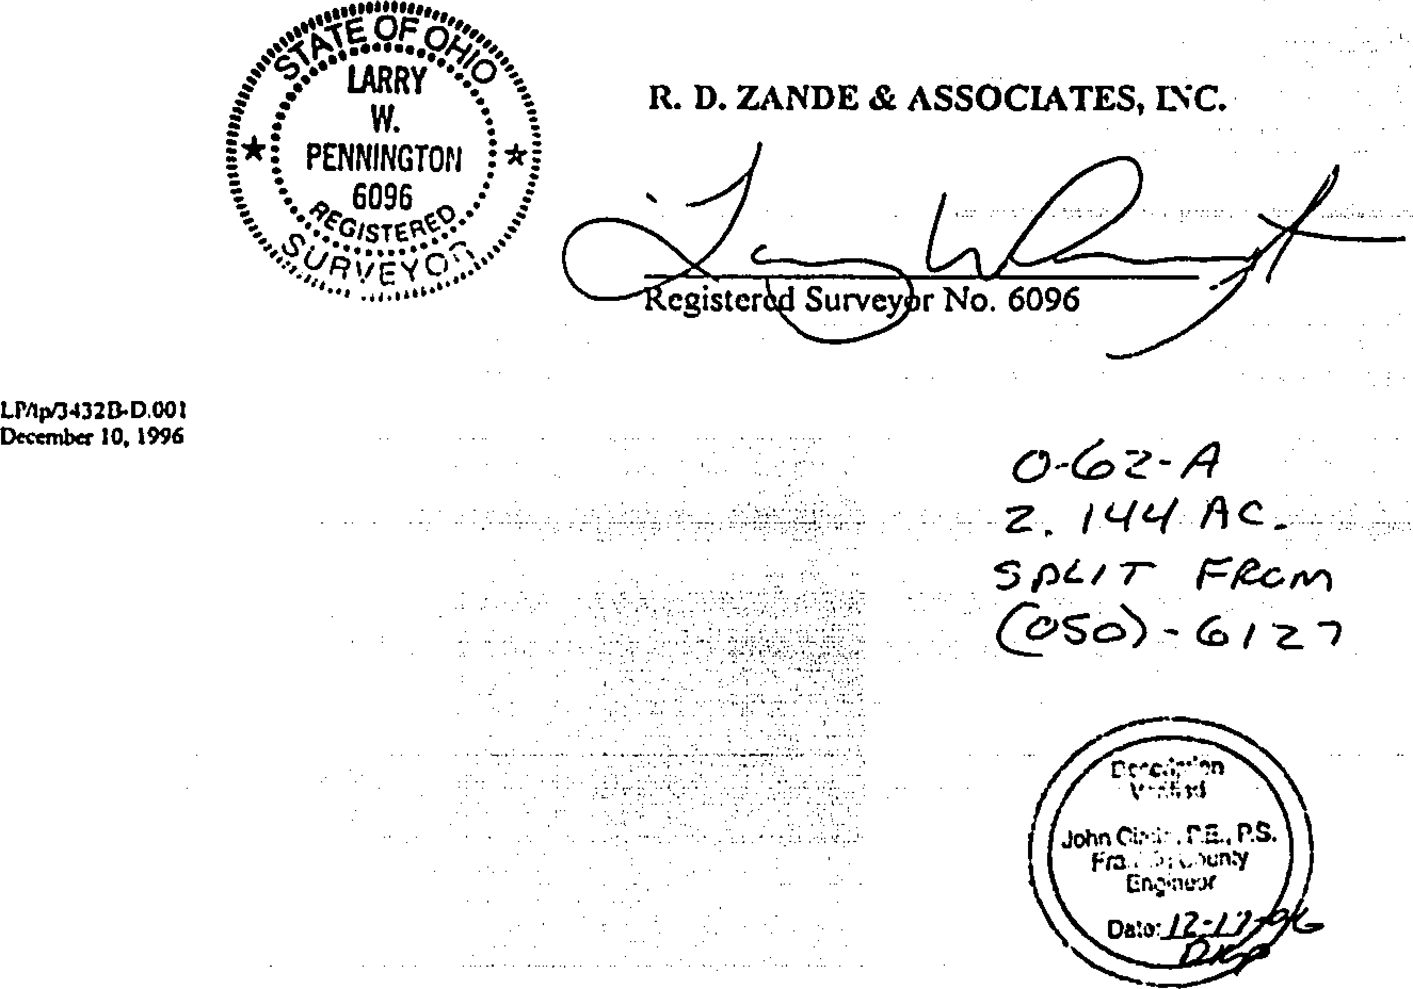

**egister r No. 6096**

**R. D. ZANDE & ASSOCIATES, LtiC.**

•

*0-6ze-4*

*z, 1446/*

**SPZ/ 7- *Fie-CM***

**rAe;..,••••!n**

**John P.S.**

***Fra* • )un:y**

**CiVotrat**

**Deo-**

**LIV1p/34320•D.001   
December 10, 1996**

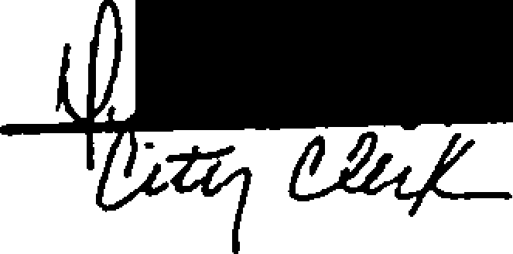**NM, Ohio. This -print hes not Swivel   
any await sr patio which *11'0,r.1:3***

**a ulster .41**

**J *mliAd***

ea)

_

**3391471507**

**EXHIBIT B**

**SCENIC COMMON AREA EASEMENT**

**Situate in the State of Ohio, County of Franklin, City of Hilliard being in *Virginia* Military Survey Number 6638 and being a strip of land on, over and across the original 53,723 acre tract {Parcel l) conveyed to Planned Development Company of Ohio by deed of record in O.R. 1632009, records of the Recorder's Office, Franklin County, Ohio and being more particularly described as follows:**

**Beginning for reference at the point of intersection of the centerline of Alton-Darby Creek Road with the centerline of Heritage Lakes Drive as shown and delineated on the record plat of "HERITAGE LAKES, SECTION 1", of record in Plat Book 79, Page 42;**

**Thence N 89° 58' 29" E, a distance of 81.03 feet, along the centerline of Heritage Laic,- Drive to a point;**

**Thence S 00° 01' 31" E, a distance of 40.00 feet, to a point in the southerly right-of-way line of Heritage Lakes Drive and being the point of true beginning for the herein described easement;**

**Thence *N* 89° 58' 29" E, a distance of 328.97 feet along the southerly right-of-way line or Heritage Lakes Drive to a point of curvature;**

**Thence continuing along the southerly right-of-way line of Heritage Lakes Drive with a curve to the left having a radius of 360.00 feet, a central angle of 24° 02' 58", the chord to which bears N 77' 57' 00" E, a chord distance of 150.00 feet to a point in the 26.852 acre tract (Parcell) conveyed • o Hilliard Lakes Golf Club Limited Partnership by deed of record in O.R. 20271CO3;**

**Thence S 32° 34' 43" W, a distance of 216.05 feet, along the westerly line of said 26.852 acre tract, to a point;**

**Thence the following seven (7) courses and distances across the said Planned Development Company of Ohio tract:**

1. **Thence S 89° 58' 29" W, a distance of 118.3 I feet, to a point;**
2. **Thence *N* 38° 17' 49* W, a distance of 83.59 feet, to a point;**
3. **Thence S 89° 13' 20" W, a distance of 96.68 feet, to a point;**
4. **Thence *N* 000 27' 34" E, a distance of 24.54 feet, to a point;**
5. **Thence N 88° 30' 48" W, a distance of 8.33 feet, to a point;**

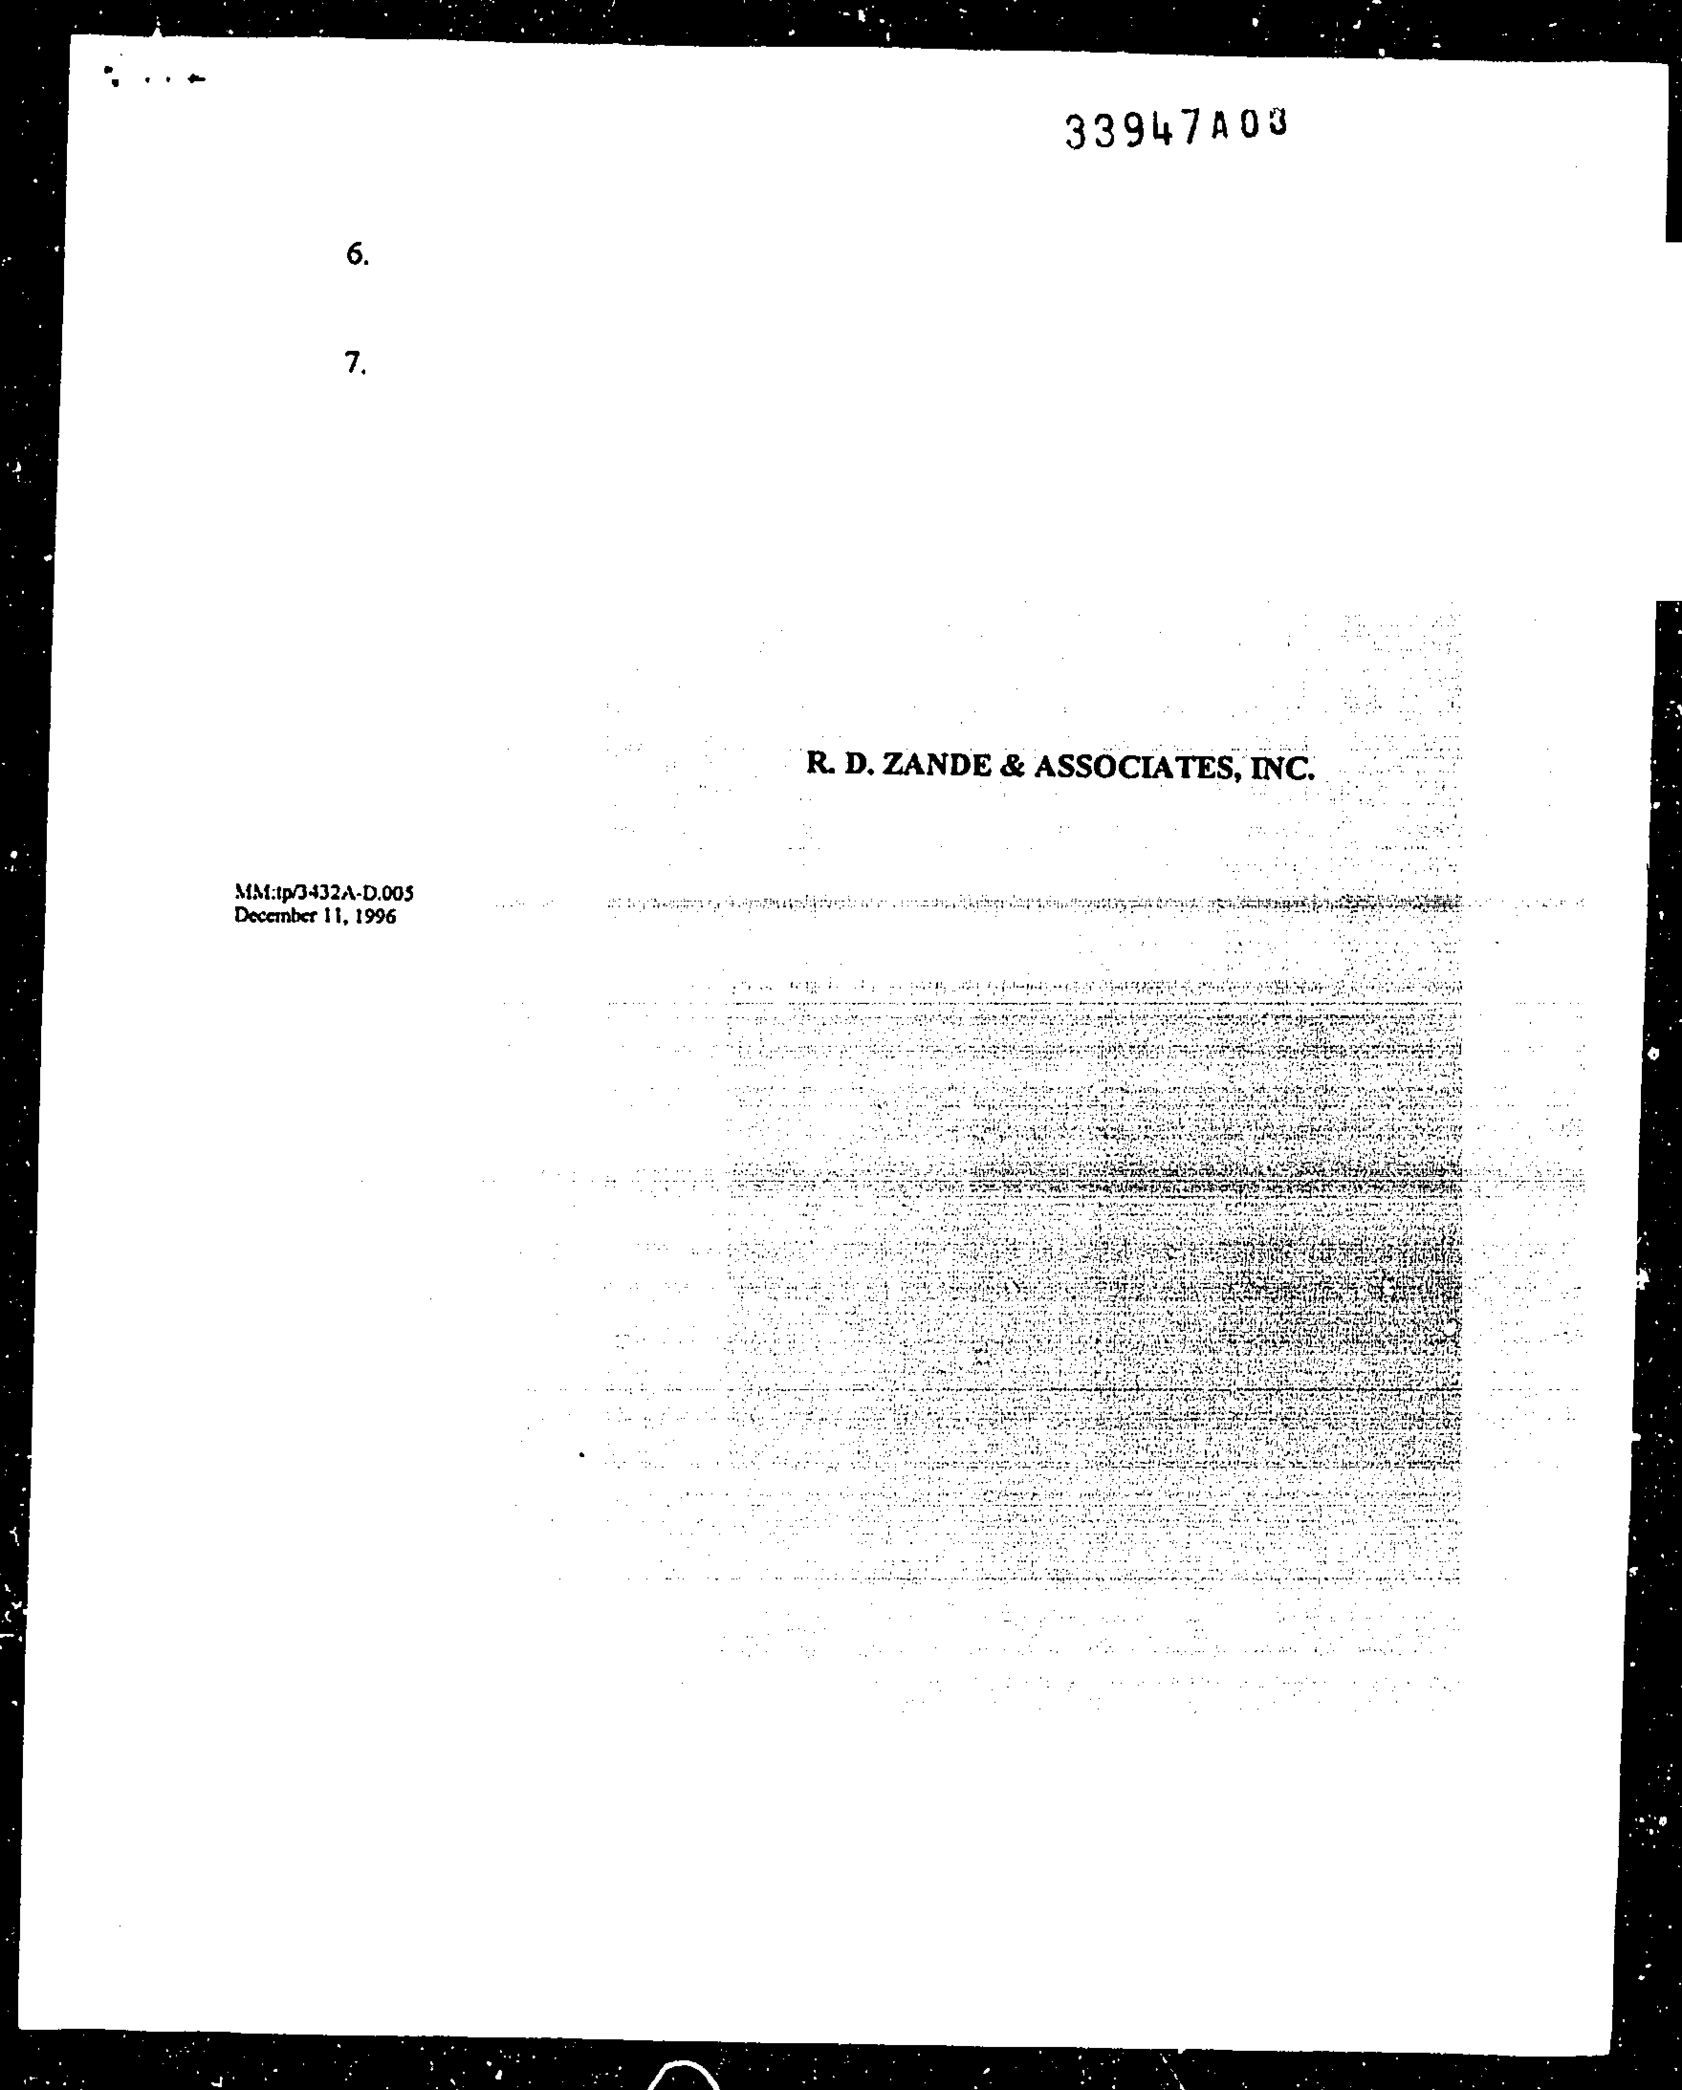**Thence N 89° 40' 30" W, a distance of 125.43 feet, to a point in the proposed easterly right-of-way line of Alton-Darby Creek Road;**

**Thence N 00° 01' 31" W, a distance of 19.85 feet, along the said proposed right-of-way line to a point of curvature in the southerly right-of-way line of Heritage Lakes Drive;**

**•**

**Thence along said right-of-way line with a curve to the right having a** radius **of 41,03 feet,**

**a central angle of 90° 00' 00", the chord to which bears N 44° 58' 29" E, a chord distance *of* 58.03 feet, to *the* point of true beginning.**

|  |  |
| --- | --- |
| **FOURTH SUPPLEMENT TO** | **111111111111111111111111111111113  Instr:199708050052963 08105/1997**  **Pages:2 Fee:$15.00 11:29AM**  **Richard B. Metcalf T19970031250  Franklin County Recorder EXCENTRAL** |

**DECLARATION OF COVENANTS, CONDITIONS   
AND RESTRICTIONS FOR HERITAGE LAKES**

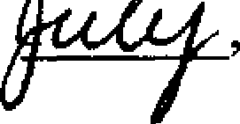**This Fourth Supplement to the Declaration of Covenants, Conditions an Restrictions for Heritage Lakes (the "Fourth Supplement") is executed and delivered this. day of**

**1997 by Planned Development Company of Ohio, an Ohio corporation ("Declarant").**

**BACKGROUND**

1. **A plan of covenants, easements, restrictions and assessments for Heritage Lakes in the City of Hilliard, Franklin County, Ohio, was created by a declaration thereof recorded in Official Records 25447-D07, Recorder's Office, Franklin County, Ohio (the "Public Records"); as amended by that certain First Supplement to Declaration of Covenants, Conditions and Restrictions for Heritage Lakes (the "First Supplement"), recorded in Official Records 27798­D03 of the Public Records; as further amended by that certain Second Supplement to Declaration of Covenants, Conditions and Restrictions for Heritage Lakes (the "Second Supplement"), recorded in Official Records 29871-H04 of the Public Records; as further amended by that certain Third Supplement to Declaration of Covenants, Conditions and Restrictions for Heritage Lakes (the "Third Supplement"), recorded in Official Records 33947,A01 of the Public Records (collectively, the "Declaration"; unless otherwise defined in this Fourth Supplement, all capitalized terms and phrases contained in this Fourth Supplement shall have the same meanings as ascribed to each in the Declaration).**
2. **Pursuant to the provisions of Section 2.2 of the Declaration, Declarant reserved**

**the right to subject additional property to the provisions of the Declaration. so**

1. **Declarant desires by this Fourth Supplement to subject the following described 8.   
   property to the provisions of the Declaration.**

**;-5 ul 8 vr**

**1 Addition to Property. Declarant thereby declares that the following described u-iri**

**real estate: To r".**

**8**

**Situated in the State of Ohio, County of Franklin and City of Hilliard, and known as Lots 105 through 147, both inclusive, of HERITAGE LAKES Section 2, Phase 2, as the same are numbered and delineated on the plat thereof in Plat Book 86, pages 80, 81 and 82, Recorder's Office, Franklin County, Ohio**

**all of which are owned by Declarant, shall be held, transferred, sold, conveyed, improved and occupied subject to all of the covenants, conditions and restrictions set forth in the Declaration and such property shall be and hereby is deemed part of the**

**CONVEYANCE TAX**

**• a - •**

**TRANSFER   
NOT NECESSARY**

**AUe 5 1997**

**JOSEPH W TESTA   
AUDITOR   
FRANKLIN COUNTY. OHIO**

**EXEM T**



JOSEP ' W. TESTA

**FRANKLIN COUNTY AUDITOR**

**2. Ratification of Declaration. Except as amended, supplemented and**

**modified by the First Supplement, the Second Supplement, the Third Supplement and this Fourth Supplement, Declarant hereby ratifies and affirms the Declaration.**

**IN WITNESS WHEREOF, this Fourth Supplement to Declaration of Covenants, Conditions and Restrictions for Heritage Lakes has been duly signed, acknowledged and delivered by Declarant as of the date set forth above.**

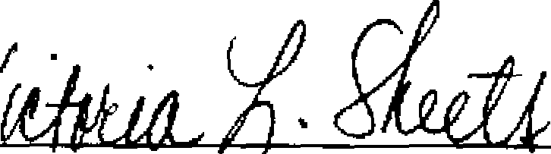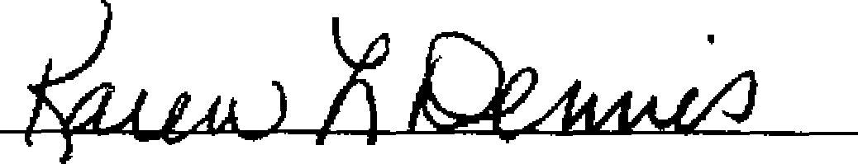**(printed name of witness #2)**

**Signed and acknowledged in**

**the presence of the following**

**two witnesses:**

**(signature of witness #1)**

*Ilte:roP1,11-* fd5

**(printed name of witness #1)**

**(signature f witness #2)**

**STATE OF OHIO**

**) SS: COUNTY OF FRANKLIN )**

**Planned Development Company of Ohio, an Ohio corporation**

**Daniel M. O'Brien, !President**



**By:**

**71.**

**The foregoing instrument was acknowledged before me this day of**

**1997 by Daniel M. O'Brien, President of Planned Development Company of hio, Ohio**

**corporation, on behalf of the corporation.**

**This Instrument Prepared by and After Recording Return to:**

|  |  |  |
| --- | --- | --- |
| **Notary Pub**  **eUIAA)** | |  |
|  | **KAREN L DENNIS**  **NOTARY PUBLIC, STATE OF OHO  MY CONSSION EXPIRES MAY IS, 2000** | |

**J. Thomas Mason, Esq.**

**Vorys, Sater, Seymour and Pease 52 East Gay Street**

**Post Office Box 1008**

**Columbus, Ohio 43216-1008**

07/28/97 - 021 1 508.01

**2**



|  |  |
| --- | --- |
| **FIFTH SUPPLEMENT TO** | **1111111111111111111111110111111111111111111  Instr:199709290104667 09/29/1997**  **Pages.3 Fee:$20.00 2.50PM**  **Richard B. Metcalf T19970053076  Franklin County Recorder BXCENTRAL** |

**DECLARATION OF COVENANTS, CONDITIONS   
AND RESTRICTIONS FOR HERITAGE LAKES**

|  |  |
| --- | --- |
| This Fifth Supplement to the Declaration of Covenants, Conditions and Restrictions for Heritage Lakes (the "Fifth Supplement") is executed and delivered this "ill day of September, 1997 by Planned Development Company of Ohio, an Ohio corporation ("Declarant"). |  |

BACKGROUND

1. A plan of covenants, easements, restrictions and assessments for Heritage Lakes in the City of Hilliard, Franklin County, Ohio, was created by a declaration thereof recorded in Official Records 25447-D07, Recorder's Office, Franklin County, Ohio (the "Public Records"); as amended by that certain First Supplement to Declaration of Covenants, Conditions and Restrictions for Heritage Lakes (the "First Supplement"), recorded in Official Records 27798­D03 of the **Public** Records; as further amended by that certain Second Supplement to Declaration of Covenants, Conditions and Restrictions for Heritage Lakes (the "Second Supplement"), recorded in Official Records 29871-H04 of the Public Records; as further amended by that certain Third Supplement to Declaration of Covenants, Conditions and Restrictions for Heritage Lakes (the "Third Supplement"), recorded in Official Records 33947,A01 of the Public Records; as further amended by that certain Fourth Supplement to Declaration of Covenants, Conditions and Restrictions for Heritage Lakes (the "Fourth Supplement"), recorded as Instrument Number 199708050062963 in the **Public** Records (collectively, the "Declaration"; unless otherwise defined in this Fifth Supplement, all capitalized terms and phrases contained in this Fifth Supplement shall have the same meanings as ascribed to each in the Declaration).
2. Pursuant to the provisions of Section 2.2 of the Declaration, Declarant reserved the right to subject additional property to the provisions of the Declaration.
3. Pursuant to the provisions of Section 9.1 of the Declaration, Declarant reserved the right to amend the Declaration.
4. Declarant desires by this **Fifth** Supplement to subject the following described property to the provisions of the Declaration and to otherwise amend the Declaration as more particularly provided in this Fifth Supplement.

DECLARATION

Addition to Property. Declarant thereby declares that the following described

i

**1.**

real estate:

TRAt'. . NOT

sEp **29 1997**

JOSFT-, .*/ •rES.-..TA   
FRANKUN COUNTY, **OHIO**

CM.II,'FvANCE TAX

E X 'Lill:. P

***A   
i***

..,

rFRAKU ------..gl3EPH ST

NN COUNTY AUDITOR

EA

Situated in the State of Ohio, County of Franklin and City of Hilliard, and known as Lots 202 through 224, both inclusive, of **FAIRWAY COMMONS AT HERITAGE LAKES,** as the same are numbered and delineated on the plat thereof in Plat Book 87 , page(s) 24 , Recorder's Office, Franklin County, Ohio; **EXCEPTING THEREFROM** those two strips of land conveyed by Declarant to Franklin County, Ohio for right-of-way purposes pursuant to that certain Quitclaim Deed recorded in the Public Records on SeptemberA , 1997 as

Instrument Number H119 NA901 OL-f *&VI*

all of which property ("Fairway Commons") is owned by Declarant, shall be held, transferred, sold, conveyed, improved and occupied subject to all of the covenants, conditions and restrictions set forth in the Declaration and such property shall be and hereby is deemed part of the Property.

1. Common Property. The islands located within the two cul-de-sacs forming a part of Fairway Commons Drive (located on the Plat described in 111 of this Fifth Supplement) shall be deemed "Common Property," as that term is defined in §1.12 of the Declaration.
2. Clarification of Article **VI.** The Second Supplement and Third Supplement each added a new Section 6.6 to the Declaration. As such, Article VI of the Declaration, titled "Easements, Rights of Entry," is hereby clarified and amended by: (i) maintaining the amendment to this Article created by the Second Amendment as Section 6.6 of the Declaration (titled "No Rights in Golf Course"), and (ii) adding a new Section 6.7 to such Article, the contents of which shall be the Scenic Common Area Easement described in ¶4 of the Third Supplement (titled "Scenic Common Area Easement").
3. Additional Easements. Article VI of the Declaration is hereby further amended by adding the following new Section 6.8 to such Article:

Section 6.8 Fence and Landscape Easement. Declarant reserves to itself, the Association and to the Golf Course Owner a perpetual easement for the construction, maintenance, repair and replacement of fencing and landscaping in, through, under and over: (i) a 20' strip of land on Lots 215 through 224, both inclusive, of Fairway Commons located east of and contiguous to the western right-of-way line for Alton Darby Road for the purpose of installing, repairing, maintaining, removing and replacing Common Property including, without limitation, fencing and landscaping, and (ii) a 5' strip of land on Lots 202 and 224 of Fairway Commons located contiguous to and south of the north property line of such lots for the purpose of installing, repairing, maintaining, removing and replacing Common Property including, without limitation, fencing and landscaping.

1. Ratification of Declaration. Except as amended, supplemented and modified by the First Supplement, the Second Supplement, the Third Supplement, the Fourth Supplement and this Fifth Supplement, Declarant hereby ratifies and affirms the Declaration.

2

IN WITNESS WHEREOF, this Fifth Supplement to Declaration of Covenants, Conditions and Restrictions for Heritage Lakes has been duly signed, acknowledged and delivered by Declarant as of the date set forth above.



Planned Development Company of Ohio, an Ohio corporation

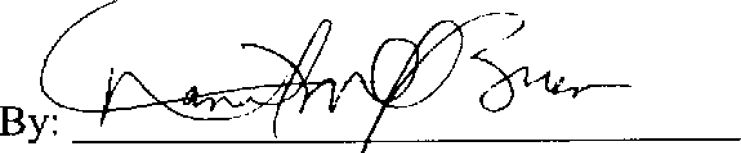

By:

Signed and acknowledged in the presence of the following two witnesses:

(signature of witness #1) Daniel M. O'Brien, President

17k)(,75 . 1/# T

(printed nweo.cwitness #1)

e2cau AuAid-,

(signs e of witness #2)

*IV* 1- AO egiVi*S*

(printed name of witness #2)

STATE OF OHIO

) SS: COUNTY OF FRANKLIN )

The foregoing instrument was acknowledged before me this  **7**  day of September,

1997 by Daniel M. O'Brien, President of Planned Development Company of Ohio, an Ohio corporation, on behalf of the corporation.

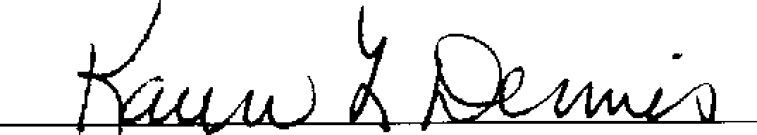

Notary Public

|  |  |  |  |
| --- | --- | --- | --- |
| This Instrument Prepared by and After Recording Return to:  J. Thomas Mason, Esq.  Vorys, Sater, Seymour and Pease 52 East Gay Street  Post Office Box 1008  Columbus, Ohio 43216-1008 |  |  | **r'7N L. DENNIS**  **r** LiBLIC, **STATE OF OHO**  **MY COivintliSSION WIRES MY 15, 2000** |
| (<)/18197 - 2218695.0 1 | 3 |  |  |

|  |  |
| --- | --- |
| **SIXTH SUPPLEMENT TO** | 11111111111111111111111111111111111111111  Instr-200212180325533 12/18/2302  Pages:3 F:$30.00 4:26PM  Robert G. Montgomery T20020147133  Franklin County Recorder BXVORYS,SA |

**DECLARATION OF COVENANTS, CONDITIONS   
AND RESTRICTIONS FOR HERITAGE LAKES**

**This Sixth Supplement to the Declaration of Covenants, Conditions and Res ictions for Heritage Lakes (the "Sixth Supplement") is executed and delivered this atit- day of**

**2002 by Planned Development Company of Ohio, an Ohio corporation ("Declarant").**

**BACKGROUND**

1. **A plan of covenants, easements, restrictions and assessments for Heritage Lakes in the City of Hilliard, Franklin County, Ohio, was created by a declaration thereof recorded in Official Records 25447-D07, Recorder's Office, Franklin County, Ohio (the "Public Records"); as amended by that certain First Supplement to Declaration of Covenants, Conditions and Restrictions for Heritage Lakes the "First Supplement"), recorded in Official Records 27798­D03 of the Public Records; as further amended by that certain Second Supplement to Declaration of Covenants, Conditions and Restrictions for Heritage Lakes (the "Second Supplement"), recorded in Official Records 29871-H04 of the Public Records; as further amended by that certain Third Supplement to Declaration of Covenants, Conditions and Restrictions for Heritage Lakes (the "Third Supplement"), recorded in Official Records 33947-A01 of the Public Records; as further amended by that certain Fourth Supplement to Declaration of Covenants, Conditions and Restrictions for Heritage Lakes (the "Fourth Supplement"), recorded as Instrument Number 199708050062963 in the Public Records; as further amended by that certain Fifth Supplement to Declaration of Covenants, Conditions and Restrictions for Heritage Lakes (the "Fifth Supplement") recorded as Instrument No. 199709290104667 in the Public Records (collectively, the "Declaration"; unless otherwise defined in this Sixth Supplement, all capitalized terms and phrases contained in this Sixth Supplement shall have the same meanings as ascribed to each in the Declaration).**
2. **Pursuant to the provisions of Section 9.1 of the Declaration, Declarant reserved the right to amend the Declaration.**
3. **Declarant desires by this Sixth Supplement to amend the Declaration to clarify certain provisions thereof as more particularly provided in this Sixth Supplement.**

**NOW, THEREFORE, Declarant hereby declares that:**

**1. Clarification of Section 13.5. In order to clarify and reaffirm that Declarant has**

**the power and authority to subject additional property to the Declaration regardless of whether Declarant owns any Lots in Heritage Lakes, Section 13.5 of the Declaration, titled**

**"Amendments", is hereby amended to read as follows:**

**TRANSFERRED   
NOT NECES,,?ARI**

**DEC 18 2002 1**

**JOSEPH W TESTA KurgauT01,7iy, OHIO**

**CONVEYANCE TAX**

**EXEMPT**

**JOSEPH V . ESTA   
FRANKLIN COUNT/ lib,OCOTOR**

11111

**"Section 13.5 AMENDMENTS. This Declaration may be amended at any time by Declarant (without the consent or approval of any Member, the Association or any other person) for the purpose of subjecting additional property to this Declaration as provided in Section 2.2 hereof; regardless of whether Declarant owns any Lot in Heritage Lakes at the time of the amendment. In addition, this Declaration may be amended at any time by Declarant as provided in Section 9.1(e) hereof without the consent or approval of any Member, the Asssociation or any other person, but subject to the limitations set forth in Section 9.1(e). In all**

|  |  |  |
| --- | --- | --- |
| **2** |  | **PAULA L. O'BRIEN**  **NOTARY PUBLIC, STATE OF OHIO  MY COMMISSION EXPIRES *FEB.* 7, 2004** |

**other instances, this Declaration may be amended in whole or in part with the approval of Members entitled to exercise not less than 75% of the voting power of all Members in the Association. Unless amended by Declarant, any such amendment shall contain a certification by the Secretary of the Association that the Members signing the amendment possess and constitute not less than 75% of the voting power of all Members in the Association. Any amendment, including an amendment by Declarant, shall become effective upon recordation thereof in the Public Records."**

**2. Ratification of Declaration. Declarant hereby ratifies and affirms the Declaration,**

**as amended, supplemented and modified by the First Supplement, the Second Supplement, the Third Supplement, the Fourth Supplement, the Fifth Supplement and this Sixth Supplement.**

**IN WITNESS WHEREOF, this Sixth Supplement to Declaration of Covenants, Conditions and Restrictions for Heritage Lakes has been duly signed, acknowledged and delivered by Declarant as of the date set forth above.**

**Planned Development Company of Ohio, an Ohio corporation**

**Daniel M. O'Brien, esident**

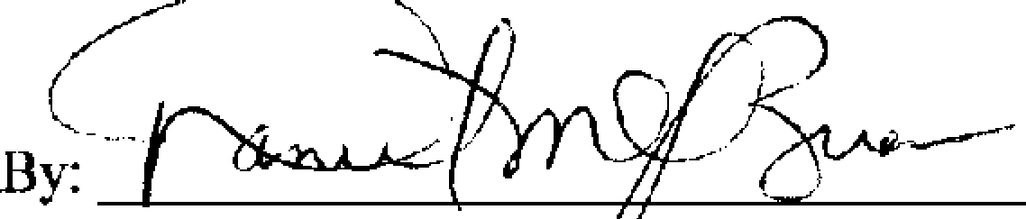

77)

**B •**

**STATE OF OHIO**

**) SS: COUNTY OF FRANKLIN )**

**The foregoing instrument was acknowledged before me this (1 6it day of .bra-1/111,64t, 2002 by Daniel M. O'Brien, President of Planned Development Company of Ohio, an Ohio corporation, on behalf of the corporation.**

Mace( 'd\ tu

**Notary Public**

This Instrument Prepared by and After Recording Return to:

Gary E. Davis, Esq.

Vorys, Sater, Seymour and Pease 52 East Gay Street

Post Office Box 1008

Columbus, Ohio 43216-1008

3